

**Division of Research**

**Comparative Medicine**

Date Released: 01/07/16 Version: 01 Date Last Revised: N/A

|  |
| --- |
| FAUSOP 205 **Aquatic Turtle Health Monitoring and Reporting** |
| **SCOPE:** This SOP is applicable to all Comparative Medicine personnel involved in the daily animal monitoring and veterinary care program.  **PURPOSE:** To describe the procedures involved in the daily health monitoring and care of aquatic turtles (freshwater or brackish water) housed in facilities operated and/or overseen by Comparative Medicine.  **EQUIPMENT:** Flash lights, penlights, Scale  **LOCATION:** Vivarium 35A, Sanson Turtle Lab  **SOP OWNER:** Attending Veterinarian |
| Approved by: Sylvia Gografe, D.V.M., Ph.D. Director Comparative Medicine |

**References**

1. *Guide for the Care and Use of Laboratory Animals*. National Research Council; National Academy Press, Washington, D.C., 2011
2. Public Health Service Policy on Humane Care and Use of Laboratory Animals. OLAW (NIH) 2015
3. AVMA Guidelines for the Euthanasia of Animals, American Veterinary Medical Association, 2013 Edition
4. Laboratory Animal Medicine. JG Fox, LC Anderson, G Otto, KR Pritchett-Corning and MT Whary, Academic Press, 3rd Edition, San Diego, CA, 2015

|  |
| --- |
| 1. **Responsibilities** 2. Animal Care Technician (ACT)    1. Adhere to procedures as outlined in this SOP.    2. Document all activities as outlined below in Recordkeeping.    3. Inform PI and/or Director immediately about any emergency and within the time limit specified in this SOP about any abnormal findings. 3. Training Coordinator/Coordinator, Administrative Services (CAS)    1. Train CM staff on this SOP regularly but at least once a year. Newly hired personnel will be trained during the initial training period as outlined in SOP 001, Training New Lab Animal Technicians.    2. Train CM staff on appropriate procedures necessary to perform health evaluations and treatments as prescribed by the veterinarian.    3. Communicates with vendor in case turtles arrived in unacceptable health conditions or not to the specifications indicated in the animal order. 4. Facilities Manager (FM)    * 1. Oversees receipt of animals into regular or quarantine housing, initial health evaluation, care/husbandry procedures, possible treatments, collection of test samples, shipping to commercial laboratory and in-house testing as directed by AV and outlined in this SOP.      2. Inform AV immediately about any equivocal or positive results of diagnostic tests and abnormal findings and/or observations.      3. Assures that responsible Animal Care Technicians are appropriately trained and implement procedures as delineated in this SOP. 5. Veterinarian/Director    1. Adhere to procedures as outlined in this SOP.    2. Ensure procedures are followed as outlined in this SOP.    3. Ensure appropriate training is provided to particular personnel performing this function.    4. Maintain direct and frequent communication with ACT and research staff; visit each facility at least once a week and more often if necessary.    5. Evaluate animals, diagnose, prescribe increased monitoring and/or treatment as necessary. Provide consultation to research staff in regards to treatment or euthanasia.    6. Review all health records and test results if applicable regularly. 6. **Safety**   GENERAL:   * Eating, drinking, chewing gum, and applying cosmetics is not permitted within the facility. * Appropriate PPE has to be worn and universal precautions followed when working with reptiles to avoid transmission of zoonotic diseases such as *Salmonella*. * Wash hands after handling animals and specimen for examination. * Turtles are capable of inflicting scratches and bites. Use caution and proper handling and restraint techniques. * In the event of a bite or a scratch, notify Supervisor immediately and complete injury report. |
|  |
|  |
|  |

**III. Procedure**

1. GENERAL
   1. Health monitoring is an important part of an animal care and use program. All animals will be monitored by Comparative Medicine at least once daily if housed in a CM centralized facility or once weekly if housed in a satellite facility maintained by the PI from the day of arrival until final disposition.
   2. Vendors of aquatic animals such as Red Eared Sliders (*Trachemys scripta*) are evaluated by the AV prior to first shipment of turtles. Shipping health reports will be filed and web health reports will be screened if applicable.
   3. If permits are required for procurement of species such as FWS permit for invasive species they will be filed along with other official documents.
   4. If turtles are not commercially available such as Terrapins, the respective PI is responsible for acquiring appropriate permits before any turtles are wild caught.
   5. Newly arrived animals are housed separately in a tank different from the resident turtles for 4 weeks or longer if directed by the veterinarian. Those turtles will be handled after the husbandry/handling of resident turtles has been finished.
   6. Arrival of animals requires that the shipping crate be sprayed with approved disinfectant prior to entry into the building. Each animal is examined for any abnormal signs while transferring from the shipping crate to the permanent cage. Any abnormalities found at this time need to be reported to the relevant research staff, the veterinarian and the Coordinator, Administrative Services.
   7. Any health concerns will be communicated with the research staff. Even if a senior person in the research lab is authorized to make decisions regarding animals the Principle Investigator will be copied on any email sent to the research lab so that she/he is aware of the particular situation.
2. DAILY HEALTH MONITORING
   1. Every day, visually inspect each tank of animals for signs of illness, injury or distress starting with resident turtles first followed by observation of newly arrived animals. Animal health checks must be completed by 10AM except for animals in quarantine unless approved by the AV or FM for special occasions like holidays.
   2. If animals need to be handled resident turtles have to be serviced first.
   3. If health concerns are noted, make a brief entry in the room log book on the relevant health record sheet. Note the unique animal identification. Be succinct and describe the condition. Refrain from diagnostic terminology.
   4. If an animal is found to be in pain, bleeding, or being unresponsive inform research staff immediately. Reach out to talk to the PI or responsible research technician via phone first. If this is not possible send an email flagged as urgent. If research staff is not responsive within a reasonable time frame depending on the case inform veterinarian via phone.
   5. Document number of animals found sick or dead on room’s *Daily Room Check Sheet*.
   6. Document sick animal case in *Animal Health and Environmental Concern form*, stating room number, animal identification, IACUC protocol number, tank number/location and who has been notified.
   7. Review the *Progress Notes* for treatment instructions and previous health related entries.
   8. Each health concern has to be reported via email to the relevant research personnel and veterinarian. Emails need to be sent once a day (if applicable) when all health concerns are likely to be known. Include information regarding health concerns and animal(s) found dead. Note: Emergency situations have to be reported separate and immediately.

1. ABNORMAL SIGNS
   1. Turtles undergo ecdysis, i.e. regular shedding of skin, as any other reptile. The turtle’s shell can look cloudy before shedding scutes or layers of shell. Turtles usually don’t shed in one piece like snakes but rather in bits and pieces. This is a normal process and must be distinguished from abnormal health conditions concerning the skin/shell of turtles.
   2. Observe the appearance and behavior of animals. Abnormal signs may include:
      1. Changes in appetite, anorexia, evidence of weight loss
      2. Pitting or rough areas of the shells, picture 1
      3. Changes in color of shells (carapace and plastron), picture 2
      4. Lethargy, unresponsiveness to external stimuli, oblivious to surroundings
      5. Reluctance to move, hiding
      6. Increased aggression with manual manipulation
      7. Swellings or evidence of tumors or growths
      8. Swollen and/or shut eye(s), picture 3
      9. Diarrhea
      10. Discharge from orifices (i.e. eyes, nose, mouth, cloaca)
      11. Difficulty breathing or audible respiratory sounds
      12. Head extended away from body

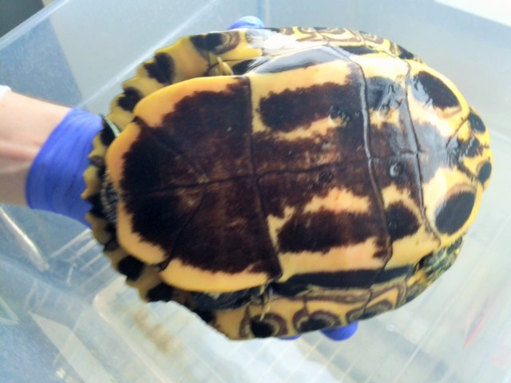

Picture 1

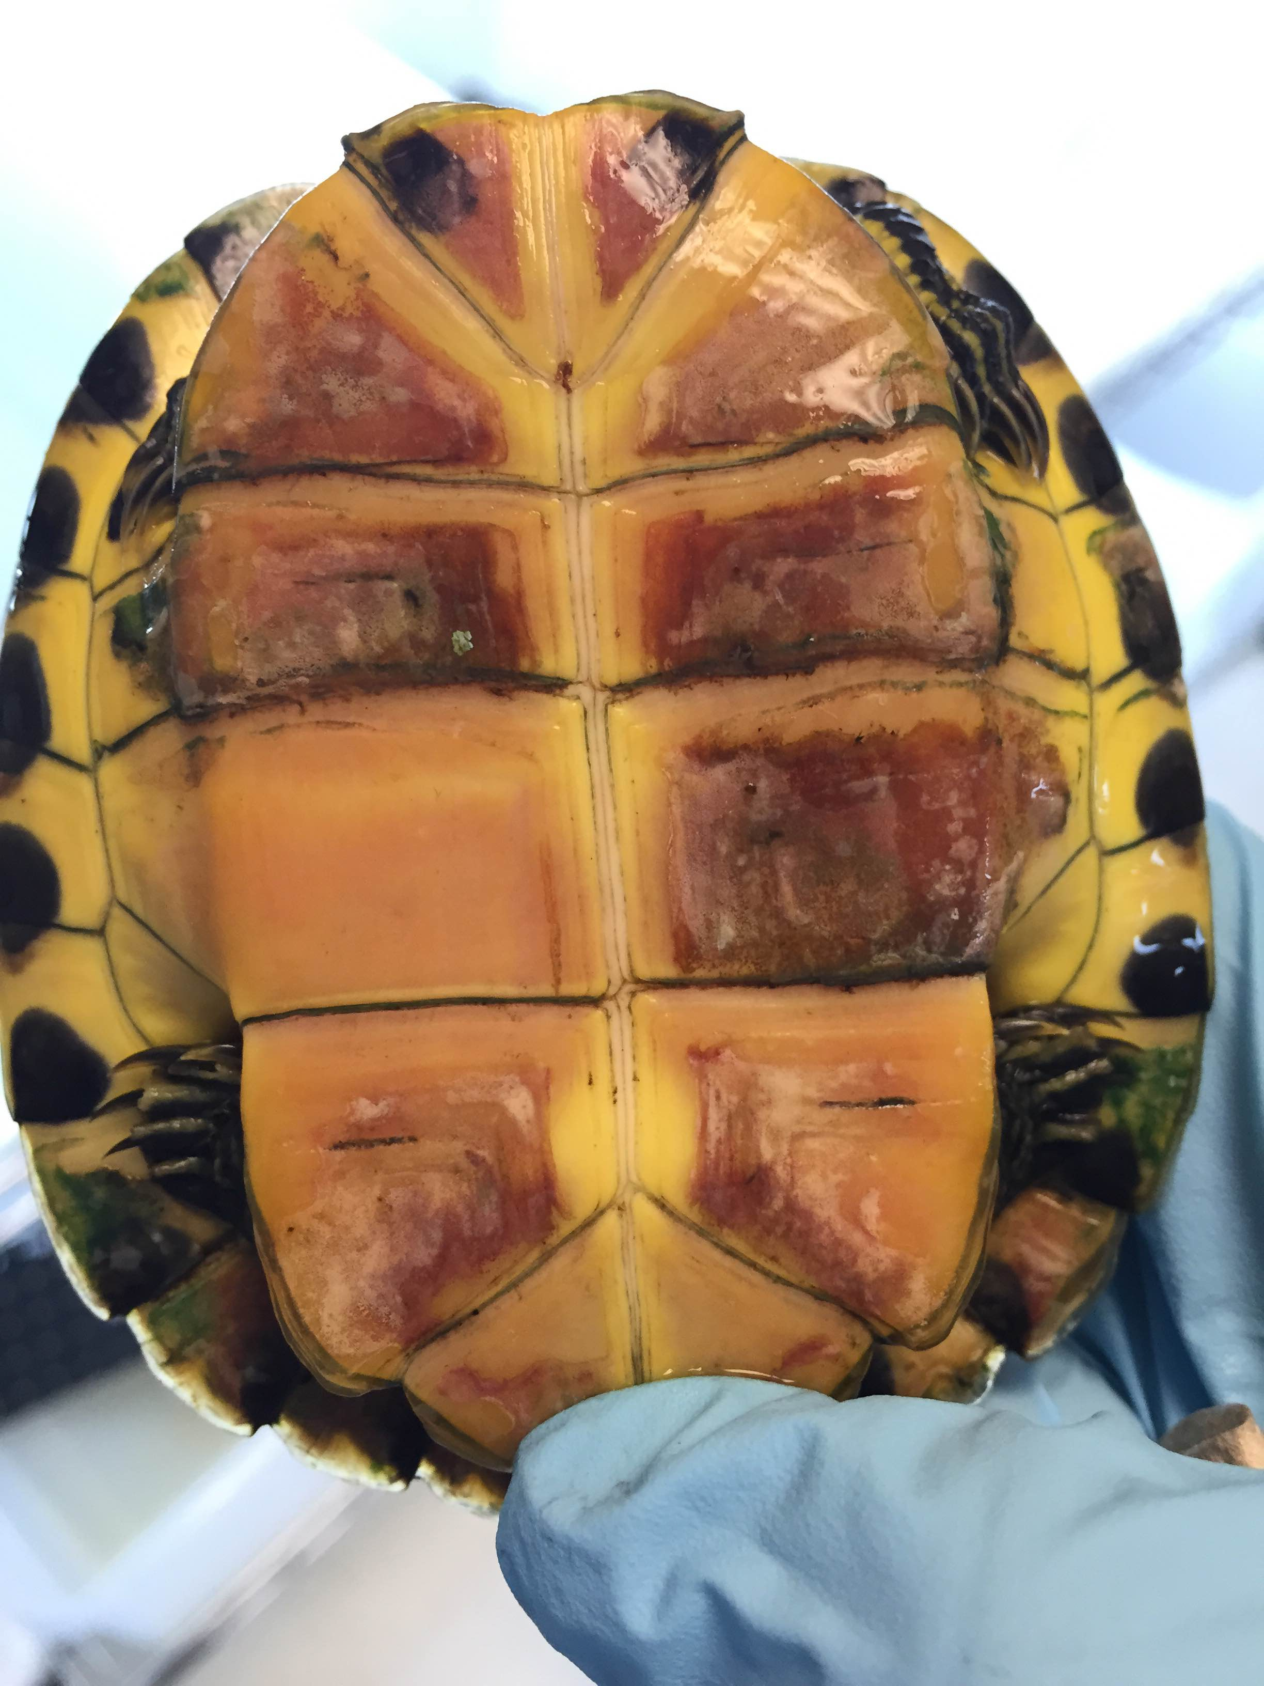

Picture 2

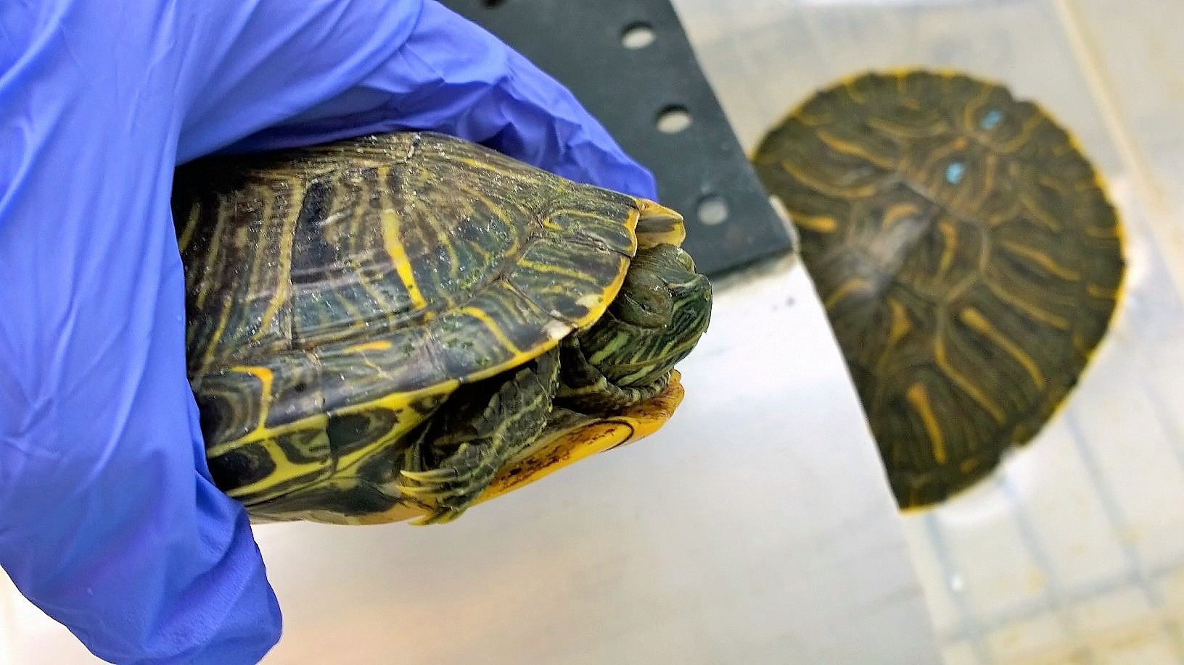

Picture 3

1. FOLLOW UP ON HEALTH CONCERNS
   1. If an animal is found moribund or in any other emergency condition, any effort will be made to contact research personnel. If this is not possible in a reasonable time, the veterinarian will make the final decision regarding euthanasia to avoid suffering of the animal.
   2. The research personnel will determine whether a sick animal should be examined by the veterinarian or euthanized.
   3. If the research personnel want to keep the animal, the veterinarian will evaluate the animal during regularly scheduled clinical rounds or earlier if warranted. The veterinarian based on her/his expertise will determine any further action necessary.
   4. If the veterinarian is not available on time, the care staff will communicate with her/him via phone/electronic media and make entries in the health records on behalf of and as directed by the veterinarian. If the responsible veterinarian is out of town a backup veterinary agreement is in place and the backup veterinarian will be contacted by the Facilities Manager or his/her designee.
   5. If the veterinarian decides that the animal needs to be euthanized, the research personnel will be informed. The expectation is that the animal will be euthanized within 24 hours of notification to allow the research staff to collect tissues unless otherwise noted in the room log book by the veterinarian.
   6. If treatment of an animal is deemed necessary the veterinarian will make written recommendations in the health records of the room log book. This recommendation will be communicated to the research staff. A response is expected within 24 hours.
   7. If the research staff objects to the recommended treatment due to interference with the study outcome the veterinarian will discuss with the Principle Investigator or authorized research personnel other possibilities including euthanasia.
   8. In case the research staff agrees on the recommended treatment Comparative Medicine personnel will treat animals housed in a CM centralized facility while research personnel is responsible for the treatment of animals housed in the satellite facility. Animals will be regularly reevaluated by the veterinarian. The veterinarian will recommend euthanasia if treatment(s) are not successful after a reasonable treatment period.
   9. If the veterinarian decides no treatment is necessary but the condition warrants close monitoring, this will be noted in the progress notes. Animal care technicians and research personnel are expected to enter observations in the progress notes at an interval as directed by the veterinarian and based on the severity of the condition. The animal will be regularly reevaluated by the veterinarian and entries made in the room log book.

1. RECORDKEEPING
   1. Any health concerns have to be noted in the *Daily Room Check Sheet* as the number of animals with health concerns and in the *Animal Health and Environmental Concern form* while in a CM centralized vivarium.
   2. Each room log book contains *Progress Notes* per PI and IACUC protocol number. *Progress Notes* will be archived once the relevant protocol expires or more often if necessary. This will be done by the party responsible for daily health monitoring and/or treatments.
   3. Comparative Medicine personnel and research personnel can perform entries in the *Progress Notes*. Entries have to be made timely, succinct and legible. Any animal with a health concern if not immediately euthanized is considered a case. Each case has to have a final entry either if the condition is resolved or the animal is euthanized to be considered closed. Animal care technicians or research personnel responsible for the particular housing area are responsible for the completeness of the health records.
   4. Treatments have to be recorded on the *Treatment label* (picture 4)*,* which will be placed as necessary by the technician responsible for treatment. The person treating the animal will enter the date of treatment and initial in the AM and/or PM column as appropriate.
   5. Records are maintained on health information for at least 3 years past the end of a protocol or essentially forever.
   6. Temporary storage of CM records is in the office of building 35A and permanent indefinite records are stored in T-5.
   7. Records of satellite facilities have to be stored at the location identified by the particular research lab.

|  |  |  |  |  |  |
| --- | --- | --- | --- | --- | --- |
| PI ________________Cage________Protocol______________ | | | | | |
| Health Issue__________________________________________ | | | | | |
| Tx ___________________________________________________ | | | | | |
|  |  |  |  |  |  |
| Date | AM | PM | Date | AM | PM |
|  |  |  |  |  |  |
|  |  |  |  |  |  |
|  |  |  |  |  |  |
|  |  |  |  |  |  |
|  |  |  |  |  |  |
|  |  |  |  |  |  |
|  |  |  |  |  |  |

Picture 4

|  |  |  |  |
| --- | --- | --- | --- |
| Review Date | Revision Date | Revision Number | Description of Revision |
|  |  |  |  |